**Font Awesome 사용법**

참조 사이트 : `https://amango.tistory.com/7`

CDN은 창

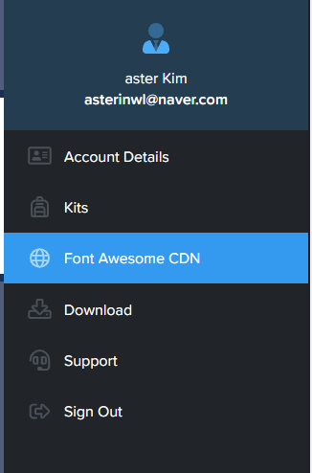

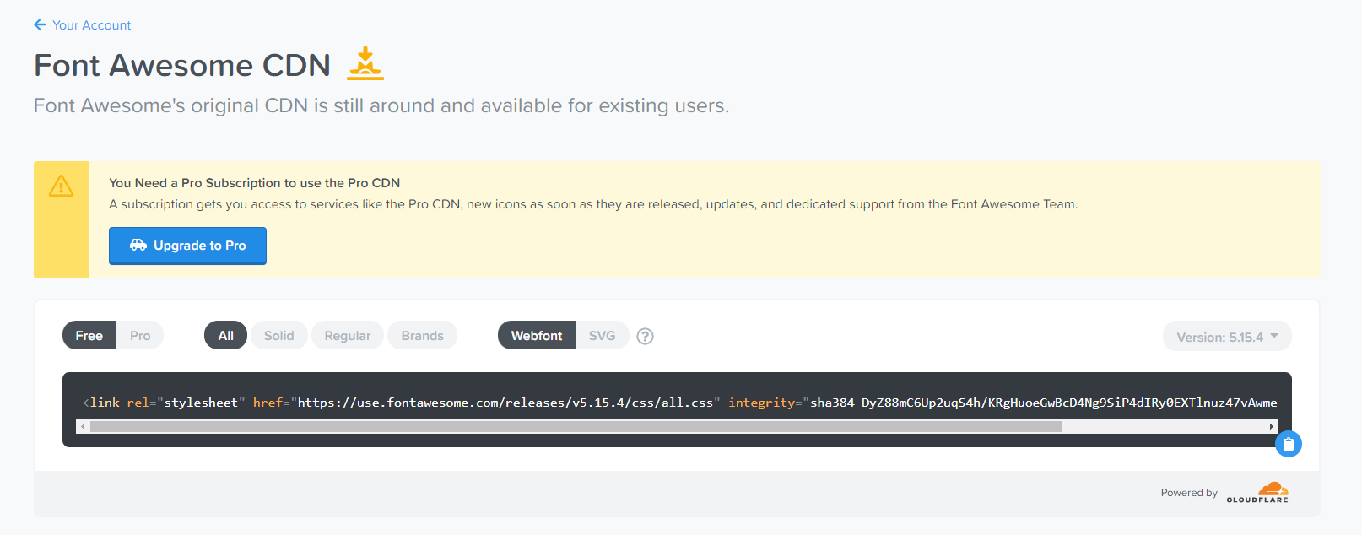

나의 CDN

`<link rel="stylesheet" href="https://use.fontawesome.com/releases/v5.15.4/css/all.css" integrity="sha384-DyZ88mC6Up2uqS4h/KRgHuoeGwBcD4Ng9SiP4dIRy0EXTlnuz47vAwmeGwVChigm" crossorigin="anonymous">`

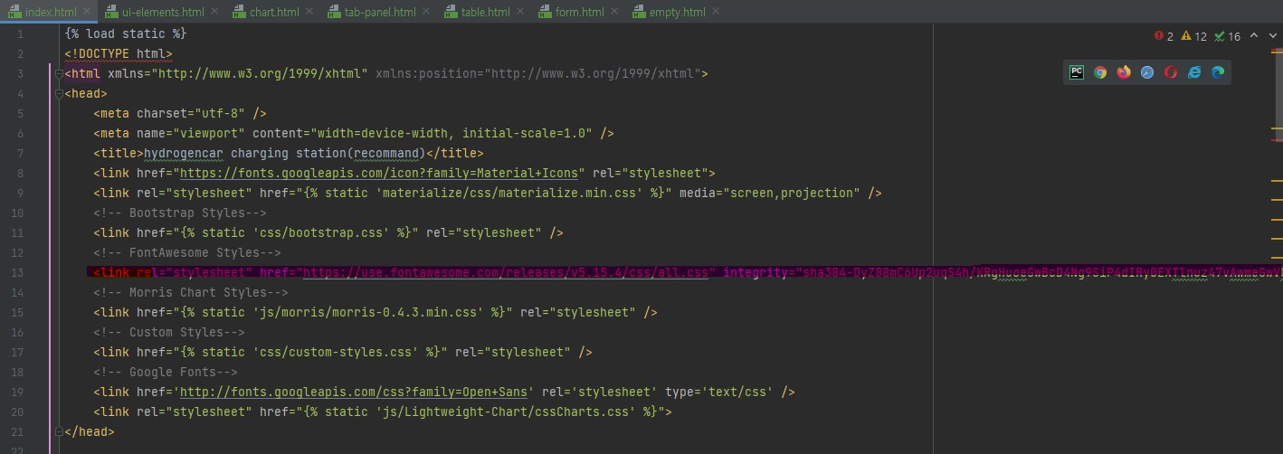

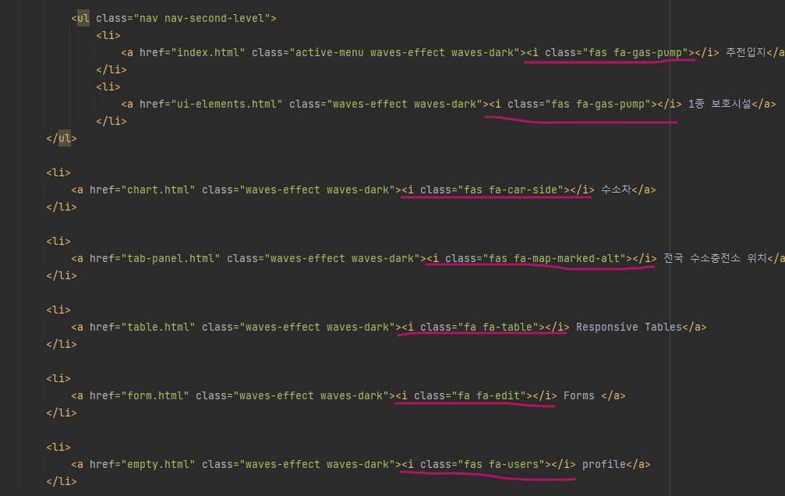

결과

